Nerve tissue, synapses, and neurotransmitters
Last edited: Sep 29, 2022
Content policy
QBANK SESSION
LEARNED

Summary
Nerve tissue consists of neurons, which are excitable cells that transmit information as electrical signals, and glial cells (e.g., oligodendrocytes, Schwann cells, astrocytes, microglial cells), which perform a variety of nonsignaling functions such as forming myelin to provide support and insulation between neurons, phagocytosing and removing cellular debris, removing excess neurotransmitters, and forming the blood-brain barrier. Oligodendrocytes myelinate neurons in the central nervous system (CNS), while Schwann cells myelinate neurons in the peripheral nervous system (PNS). Myelin sheaths increase the conduction velocity of signals across axons. Inflammation and loss of the myelin sheath are the underlying pathologic processes in multiple sclerosis (CNS) and Guillain barre syndrome (PNS). Neurons are composed of dendrites, cell bodies, axons, and axon terminals. Based on their conduction velocity, diameter, and myelination, nerve fibers (axons) are classified into large, myelinated fibers with fast conduction velocity (group A); small, myelinated fibers with slow conduction velocity (group B); and small, unmyelinated fibers with slow conduction velocity (group C). Neurons communicate through the transmission of action potentials across junctions between them called synapses. Synaptic transmission can be chemical or electrical. Chemical synaptic transmission is the transfer of signals through the release of neurotransmitters (e.g. acetylcholine, dopamine, norepinephrine) from presynaptic terminals to postsynaptic receptors. Electrical synaptic transmission is the transfer of electrical signals through gap junctions. Alterations in neurotransmitter levels have been observed in various neurological diseases, including Parkinson disease (decreased dopamine), schizophrenia (increased dopamine), depression (decreased dopamine, norepinephrine, and serotonin), and Alzheimer disease (decreased acetylcholine).
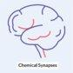
https://www.youtube.com/watch?v=Jru5dJXrPR4

Nerve tissue

General
- Nerve tissue is the main tissue component of the nervous system and is primarily composed of neurons and supporting glial cells.
- The nervous system is divided into two main components:
  - Central nervous system (CNS): consists of the brain and spinal cord
  - Peripheral nervous system: consists of the nerves and ganglia outside the brain and spinal cord, including the cranial nerves, spinal nerves, and their roots, peripheral nerves, and neuromuscular junctions

Neurons
- Description
  - Polarized, signal-transmitting cells that comprise the central and peripheral nervous system
  - Classified into unipolar, pseudounipolar, bipolar, and multipolar depending on the number of protoplasmic processes (neurites)
  - Do not undergo mitosis
  - Composed of soma (cell body), axon and dendrites
  - Nissl staining positive in the cell body and dendrites, which have Nissl substance (aggregates of rough endoplasmic reticulum with bound polysomes)
- Parts
  - Soma: contains the cell organelles
    - Has Nissl substance
    - Pigments: melanin, lipofuscin
    - Cytoskeleton: microfilaments
  - Axon: the projection from a neuron's cell body along which action potentials travel to send intercellular signals
    - Connected to the cell body at the axon hillock, which is a trigger zone for initiation of action potentials , and ends in a synapse
    - Lacks a regular rough endoplasmic reticulum and thus does not contain Nissl substance ^{[1]}
    - Cytoskeleton
      - Microtubules with associated motor proteins for rapid axonal transport
        - Kinesin: anterograde transport (– → +)
        - Dynein: retrograde transport (+ → –)
      - Neurofilaments
        - Provide structural support
        - Most abundant in axons and the proximal part of dendrites
        - Neurofilament protein is used as a marker for neuronal cells.
  - Dendrites
    - Branching, thin projections from the cell body of neurons that receive input from neighboring neurons and transmit it to the cell body
    - Contain spines that increase the number of synapses to other neurons
    - Have Nissl substance
    - Cytoskeleton: microfilaments
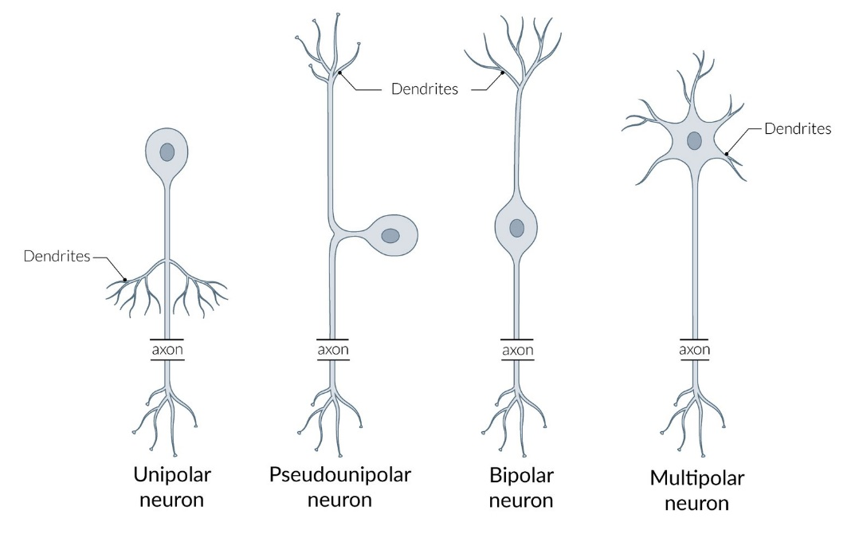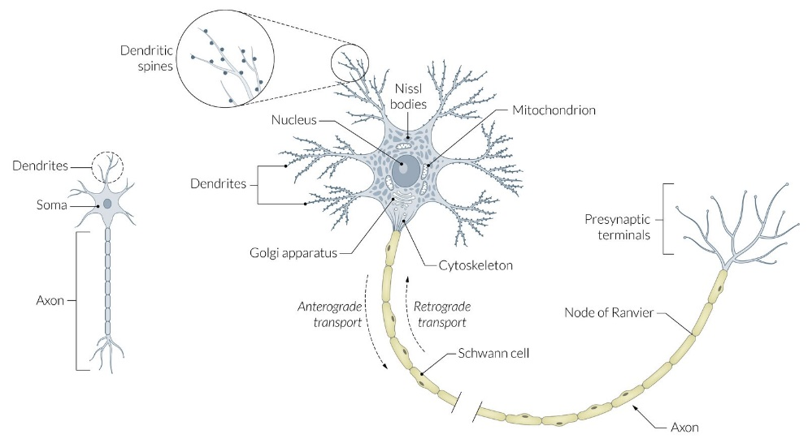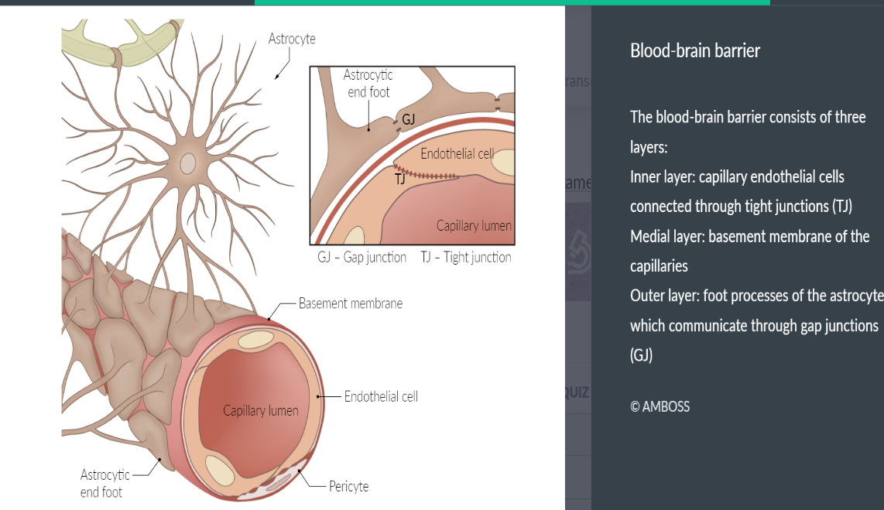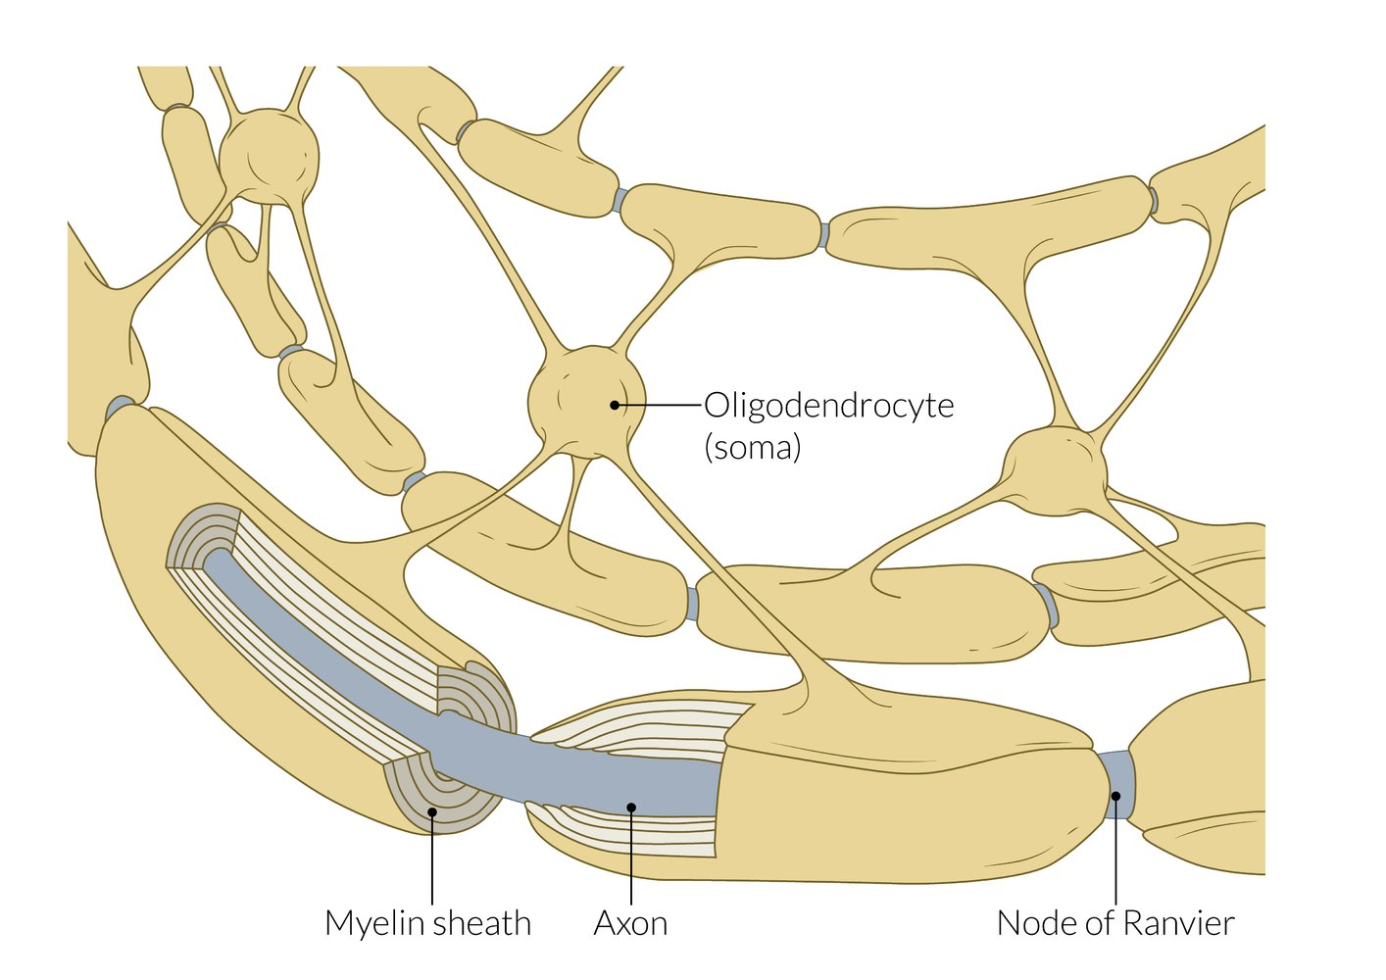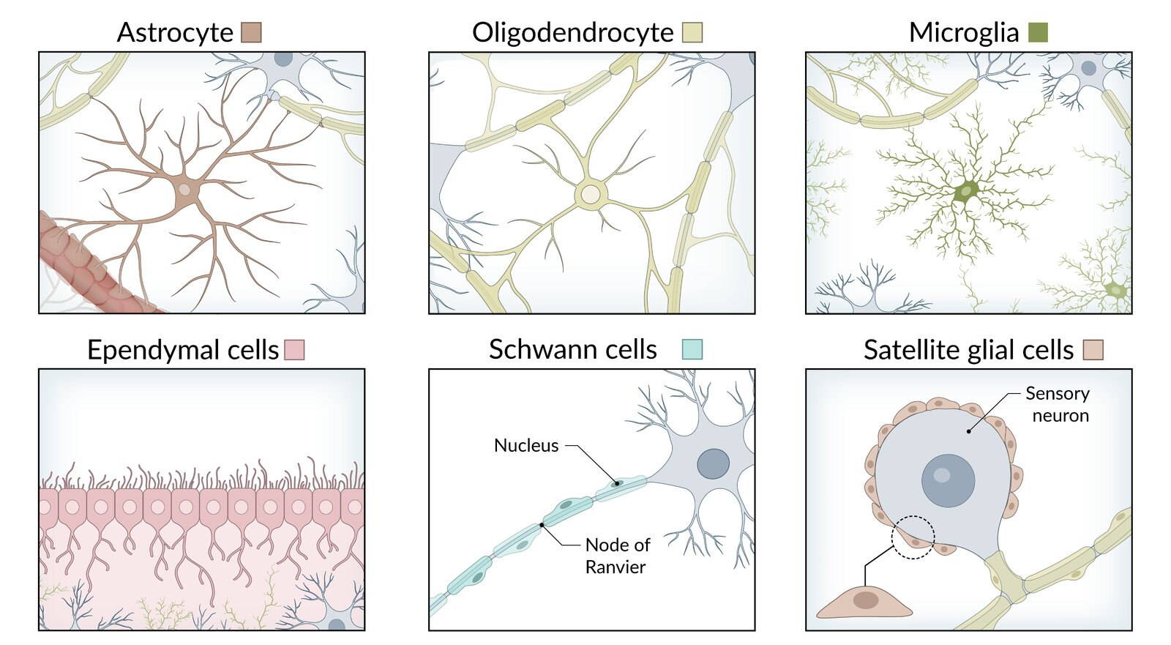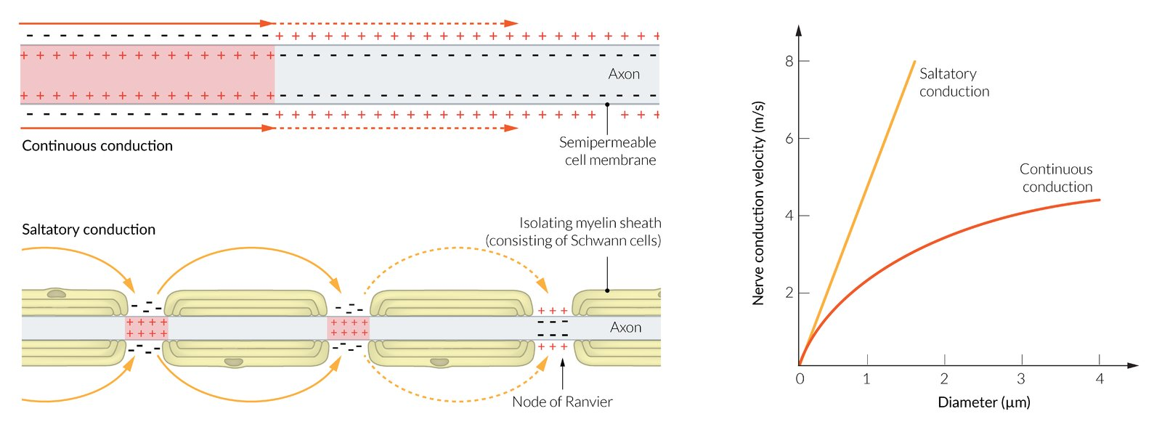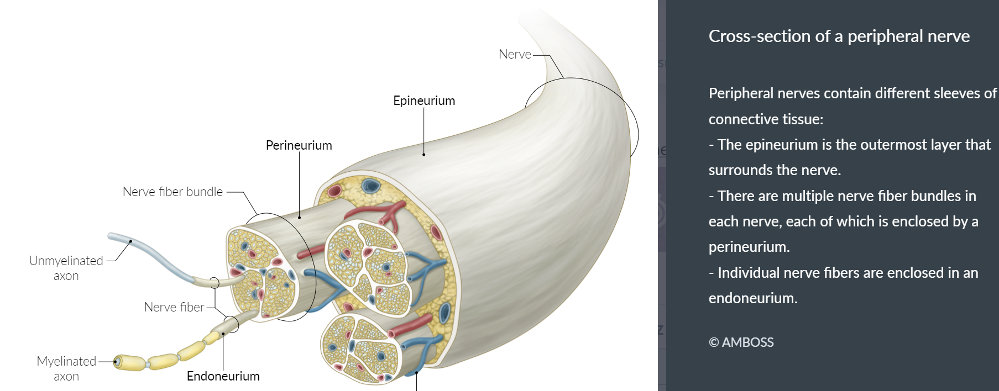

Supporting glial cells
MAXIMIZE TABLETABLE QUIZ
Cells of nerve tissue
Structure | Precursor | Characteristics | Clinical relevance
Central
Astrocytes | - Radial glial cells from neuroepithelium (neuroectoderm) | - Most abundant type of glial cells  - Have a large number of projections  - Provide physical support (scaffolding of the CNS)  - Provide extracellular potassium buffer  - Remove excess neurotransmitters  - Contain glycogen reserve  - Contain bundles of intermediate filaments composed of glial fibrillary acidic protein (GFAP; an astrocyte marker)  - Proliferate and become hypertrophic after CNS injury  - Involved in nervous tissue repair  - Reactive gliosis → form of astroglial scars  - Foot processes form part of the blood-brain barrier and the glial-limiting membrane | - Astrocytoma
Microglia | - Bone marrow monocytes (mesoderm) | - Smallest type of glial cells  - Poorly identified with Nissl stain  - Phagocytic cells  - Activated in response to CNS tissue damage  - Proliferate and migrate to damaged CNS to remove cellular debris  - Release inflammatory mediators (e.g., nitric oxide) and signaling molecules (e.g., glutamate) | - Target cells for the HIV-1 virus: Infected cells fuse to form multinucleated giant cells, which are the most specific histological marker of HIV encephalitis and HIV-associated dementia. ^{[2]}
Ependymal cells (ependymocytes) and choroid epithelial cells | - Neuroepithelial cells (neuroectoderm) | - Simple columnar glial cells  - Form the epithelium lining the ventricles and central canal of the spinal cord  - Apical surface  - Cilia circulate CSF  - Microvilli increase the capacity of CSF absorption  - Modified ependymal cells known as the choroid plexus produce cerebrospinal fluid | - Ependymoma
Tanycytes | - Radial glial cells from neuroepithelium (neuroectoderm) | - Transport substances between the blood and the ventricles  - Located mainly on the floor of the third ventricle, in contact with hypothalamic neurons  - Play a role in glucose homeostasis | - Metabolic diseases (e.g., type 2 diabetes) ^{[3]}
Oligodendrocytes | - Neuroepithelial cells (neuroectoderm) | - Myelinate axons in the CNS, including CN II  - Main glial cells in the cerebral white matter  - Each projection of a cell can myelinate several axons (30 on average, up to 60). ^{[4]}  - Increase speed of conduction and saltatory conduction  - Fried-egg appearance on histology: prominent nucleus and clear, pale cytoplasm  - Unmyelinated axons are not covered by oligodendrocyte cytoplasm. | - Oligodendroglioma  - Multiple sclerosis  - Progressive multifocal leukoencephalopathy (PML)
Peripheral
Schwann cells | - Neural crest cells (ectoderm) | - Myelinate axons of the PNS, including CN III–XII  - Each cell can myelinate one single internodal segment for one single axon.  - Promote repair after nerve injury ^{[5]}  - Unmyelinated axons are covered by Schwann cell cytoplasm.  - Can phagocytose debris after injury  - Marker: S100 | - Guillain-Barré syndrome (GBS)  - Acoustic neuroma (vestibular schwannoma)
Each myelinating SchwONE cell insulates only ONE axon.
Glial cells guard the axons of the nerve cells as COPS: CNS axons are myelinated by Oligodendrocytes; PNS axons are insulated by Schwann cells.
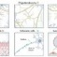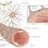

Myelin
- Insulating layer of modified plasma membrane that wraps around axons of nerve in a spiral structure
- Increases the space constant and the conduction velocity of signals traveling down axons
- Decreases membrane capacitance and increases membrane resistance
- Node of Ranvier
  - Unmyelinated regions between two adjacent myelinated segments of axons in the CNS and PNS
  - Contain a large amount of Na+ channels: allows saltatory conduction → increases the velocity of action potentials
- Demyelination: a process in which myelin sheaths of nerves become damaged, which impairs electrical conduction
  - Central demyelination occurs within the CNS (e.g., seen with multiple sclerosis, progressive multifocal leukoencephalopathy, leukodystrophies).
  - Peripheral demyelination affects the PNS (e.g., seen with Guillain-Barré syndrome).
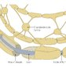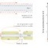

Neuronal damage
- Responses to damage
  - Cellular swelling
  - Peripherally located nucleus
  - Spread of Nissl substance throughout the cytoplasm of the neuron (chromatolysis)
  - The distal injured part of the neuron undergoes Wallerian degeneration.

Layers of peripheral nerves
- Endoneurium
  - Thin inner layer of connective tissue around a single nerve fiber
  - Clinical significance: contains inflammatory infiltrate in Guillain-Barre syndrome
- Perineurium
  - Layer of connective tissue around nerve fascicles
  - Contains the blood-nerve barrier
  - Clinical significance: important layer in microsurgery during limb salvage surgical procedures
- Epineurium
  - Outer layer of dense connective tissue around a nerve
  - Contains nerve fascicles and blood vessels to the nerve
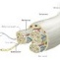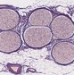
NOTES
FEEDBACK

Classification of nerve fibers
Nerve fibers are classified based on their conduction velocity, diameter, and axon characteristics.
MAXIMIZE TABLETABLE QUIZ
Classification of nerve fibers
Nerve fibers | Myelinated | Characteristics | Conduction velocity | Size
A-alpha fibers | - Yes | - Afferent: muscle spindles  - Efferent: alpha motor neurons | - 60–120 m/s | - 15 μm
A-beta fibers | - Yes | - Afferent: cutaneous mechanoreceptors | - 30–60 m/s | - 8 μm
A-gamma fibers | - Yes | - Efferent: muscle spindles (gamma motoneurons) | - 2–30 m/s | - 5 μm
A-delta fibers | - Yes | - Afferent: pain (e.g., thermal, mechanical )  - Free nerve endings  - Responsible for the withdrawal response to pain (e.g., rapidly moving the hand when burned) | - 2–30 m/s | - 3 μm
B fibers | - Moderately | - Efferent: preganglionic sympathetic fibers | - 3–15 m/s | - < 3 μm
C fibers | - No (lack of myelin creates the slow conduction as the saltatory conduction is not present) | - Afferent: pain (e.g., chemical, thermal, mechanical) | - 0.25–1.5 m/s | - 1 μm
C fibers have a slow conduction velocity due to their small diameter and lack of myelination.
NOTES
FEEDBACK

Neurotransmitters

Neurotransmitters
Neurotransmitters are endogenous substances that allow communication between neurons and, usually, induce a change in the target cell. There are two types of neurotransmitters:
- Conventional neurotransmitters: molecules that follow conventional synaptic transmission (see chemical synapse below)
  - Small molecule neurotransmitters: GABA, dopamine, norepinephrine, epinephrine, serotonin, histamine, ATP, glutamate, aspartate, adenosine, and acetylcholine
  - Neuropeptides: endorphins, enkephalins, substance P, and neuropeptide Y
- Unconventional neurotransmitters: molecules that are not stored in synaptic vesicles, may carry messages from the postsynaptic to the presynaptic neuron and can cross the cell membrane, acting directly on molecules inside the cells.
  - Endocannabinoids
  - Gasotransmitters: nitric oxide and carbon monoxide
MAXIMIZE TABLETABLE QUIZ
Overview of neurotransmitters
Neurotransmitter | Site of action | Characteristics
Acetylcholine | - Preganglionic sympathetic synapses  - Neuromuscular junction  - Parasympathetic synapses | - Usually excitatory  - Synthesized from choline and acetyl coenzyme A.  - Two receptors  - Nicotinic AChR  - Muscarinic AChR
Aspartate | - CNS | - Excitatory
Dopamine | - CNS  - Local chemical messenger in other organ systems (e.g., increases natriuresis in the kidney) | - Both excitatory and inhibitory  - Involved in initiation of movement  - Inhibits the secretion of prolactin by the anterior pituitary upon release by the hypothalamus
Endorphins | - CNS | - Endogenous opioids produced by the CNS and pituitary gland  - Inhibit pain
Enkephalins | - CNS | - Inhibit pain
GABA | - CNS | - Inhibitory  - Is mainly synthesized from glutamate via the enzyme glutamate decarboxylase
Glutamate | - CNS | - Two types  - Ionotropic glutamate receptors (iGluR)  - Excitatory glutamate-gated ion channels  - Three subtypes:  - N-methyl-D-aspartate receptor (NMDA-R)  - Quisqualate receptor (AMPA-R)  - Kainate receptors  - Metabotropic glutamate receptors (mGluR): excitatory or inhibitory G-protein coupled receptors  - Involved in long-term potentiation (e.g., learning, addiction) and neuronal excitotoxicity
Glycine | - Spinal cord  - Brainstem  - Retina | - Inhibitory
Norepinephrine | - Postganglionic sympathetic synapses  - CNS | - Neurotransmitter and hormone
Epinephrine | - CNS | - Neurotransmitter and hormone
Serotonin | - CNS | - Involved in sleep, mood, and pain inhibition  - Inhibitory

Neurotransmitter receptors (neuroreceptors)
- Definition: a membrane receptor protein that is activated by a neurotransmitter
- Characteristics
  - Membrane-bound, activated by the binding of neurotransmitters
  - Found on presynaptic and postsynaptic neuronal membranes
  - Open or close ion channels, producing electrical signals
  - Excitatory and inhibitory responses are determined by the class of ion channel and by the concentration of permeant ions inside and outside the cell.
- Types of receptors
  - Ionotropic receptors (ligand-gated ion channels): form channels through which ions, e.g., Na⁺ and Ca²⁺, flow
  - Metabotropic ion receptors (G-protein coupled receptors): are coupled to intracellular G proteins that are activated upon binding to a ligand
  - Other: presynaptic receptors (autoreceptors)
    - Respond to the transmitter released by the same neuron
    - Regulate neurotransmitter release, synthesis, or impulse flow
    - Considered a homeostatic feedback mechanism
MAXIMIZE TABLETABLE QUIZ
Overview of neurotransmitter receptors ^{[6]}
 | Ionotropic receptors | Metabotropic receptors
Characteristics | - Allosteric binding site  - The receptor molecule is also an ion channel (channel-linked). | - Signal transduction mechanisms, usually G-proteins, to activate intracellular events using a second messenger  - The receptor and ion channel are separate molecules.
Receptor opening time | - Fast | - Slow
Response | - Short-lasting postsynaptic potentials (PSPs) or fast PSPs | - Long-lasting postsynaptic or slow PSPs
Target effect location | - Within the immediate region of the receptor | - Effects can be more widespread and persistent throughout the cell
Receptor examples | - Nicotinic acetylcholine  - GABA_{A}  - 5-HT3 receptor  - Glycine  - Glutamate | - Glutamate  - Muscarinic acetylcholine  - GABA_{B}  - α and β norepinephrine and epinephrine receptors  - Histamine  - Dopamine  - Neuropeptides

Ion channels ^{[6]}
- Definition: transmembrane proteins with a narrow pore that selectively permits particular ions to permeate the membrane
- Functions
  - Give rise to selective ion permeability changes
  - Detect the electrical potential across the membrane
  - Involved in changing of local transmembrane potentials
- Types of channels
  - Voltage-gated ion channels: selectively permeable to the major physiological ions (K⁺, Na⁺, Ca²⁺, Cl⁻), responding to changes in membrane potential (e.g., depolarization, hyperpolarization); e.g., Na⁺ and Ca²⁺ channels
  - Ligand-gated ion channels: cell-surface ion channels that increase ion flux in response to ligand or drug binding to, e.g., G-protein-gated neurotransmitter receptors
  - Mechanically-gated ion channels: transmembrane ion channels that are activated by changes in the structure of the membrane and allow the passage of ions when open. Mechanically-gated ion channels are generally specific to one of the major physiological ions (K⁺, Na⁺, Ca²⁺, Cl⁻).

Clinical significance of neurotransmitter changes
MAXIMIZE TABLETABLE QUIZ
Overview of the clinical significance of neurotransmitter changes
Neurotransmitter | Site of action | Associated conditions
Neurotransmitter | Site of action | Increased levels | Decreased levels
Acetylcholine | - Basal nucleus of Meynert (forebrain)  - Neuromuscular junction | - Parkinson disease | - Alzheimer disease  - Huntington disease
Dopamine | - Substantia nigra, mainly pars compacta (midbrain)  - Ventral tegmental area (midbrain) | - Schizophrenia  - Huntington disease | - Depression  - Parkinson disease
Norepinephrine | - Locus coeruleus (pons) | - Anxiety | - Depression
Serotonin | - Raphe nucleus (medulla, pons) | - Serotonin syndrome | - Anxiety  - Depression: some antidepressants act by increasing synaptic serotonin by selectively inhibiting serotonin reuptake (SSRIs; e.g., escitalopram)  - Parkinson disease ^{[7]}
GABA | - Nucleus accumbens (basal ganglia) | - N/A | - Anxiety  - Huntington disease
NOTES
FEEDBACK

Synapses

Definitions
- Synapses: the junction across which signals or action potentials are transmitted from a presynaptic to a postsynaptic structure (e.g., neurons, muscle).
- Synaptic transmission: the process of communication between two neurons, involving the release of a neurotransmitter by the presynaptic neuron and the neurotransmitter binding to receptors on the postsynaptic membrane
- Fast neurotransmission: direct activation of a ligand-gated ion channel by a neurotransmitter
- Neuromodulation: occurs when a neurotransmitter binds to a G-protein-bound receptor and activates a chemical signaling cascade

General
- There are two types of synapses: chemical and electrical
- Synapses can further be classified according to the structures between which they signal:
  - Axodendritic synapses: signal between axons and dendrites
  - Axoaxonic synapses: signal between axons
  - Axosomatic synapses: signal between axons and the cell body of neurons
  - Dendrodendritic synapses: signal between dendrites
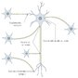

Chemical synapses
A type of synapse that transmits signals between neurons separated by a cleft via a chemical neurotransmitter

Overview
- Composed of a presynaptic membrane, a synaptic cleft (the space between a presynaptic and postsynaptic neuron), and postsynaptic membrane
- Most neurotransmitters (e.g., GABA, glutamate, glycine) undergo the following steps: synthesis, storage, release, reuptake, and degradation

Mechanism (presynaptic and postsynaptic receptor interactions)
- Neurotransmitter synthesis
  - Occurs in the presynaptic neuron
  - A precursor amino acid accumulates into the neuron.
  - The precursor is metabolized sequentially and yields a mature transmitter.
- Neurotransmitter storage
  - Vesicles filled with neurotransmitters are stored in the presynaptic terminal and to be released in response to stimulation of the neuron
  - Synaptophysin is a major synaptic vesicle protein that is thought to play a role in synaptic vesicle formation and maintenance ^{[8]}
    - Expressed throughout the brain
    - Used as a marker for neuronal cells as well as neuroendocrine tumors
- Neurotransmitter release
  - Action potentials in the presynaptic cell trigger the opening of voltage-gated Ca²⁺ channels in the presynaptic membrane, permitting Ca²⁺ influx.
  - Ca²⁺ binds to synaptotagmin (a protein anchored in the vesicle membrane), which initiates the vesicle docking to the presynaptic membrane and formation of SNARE complex. ^{[9]}
  - SNARE complex
    - Stands for Soluble NSF Attachment protein REceptor complex
    - Consists of several SNARE proteins, which are attached to either:
      - The vesicle membrane (v-SNARE proteins; e.g., synaptobrevin)
      - The presynaptic target membrane (t-SNARE proteins; e.g., syntaxin 1, SNAP 25 )
      - v-SNARE and t-SNARE proteins combine at the presynaptic membrane to form the SNARE complex.
  - During SNARE complex formation, the vesicle membrane and the presynaptic membrane merge, causing neurotransmitters to be released into the synaptic cleft.
- Neurotransmitter binding and recognition by target receptors
  - Neurotransmitters act on receptors on the postsynaptic membrane, resulting in the influx of ions into the postsynaptic cell.
  - An action potential is created on the postsynaptic cell, completing the passage of the neurotransmitter from the presynaptic to the postsynaptic cell.
- Termination of the action of the released transmitter
  - Neurotransmitter actions may be terminated by the following three interlinked processes.
    - Neurotransmitter reuptake: an active termination process triggered by specific transporter proteins on the presynaptic neuron or on glial cells where the neurotransmitter is stored
    - Neurotransmitter enzymatic degradation: a termination process triggered by enzymes in the synaptic cleft (e.g., acetylcholinesterase) yielding an inactive substance
    - Neurotransmitter diffusion: a dispersal of the neurotransmitter out of the synaptic cleft
- Postsynaptic potentials (PSPs)
  - The postsynaptic response depends on the type of channel coupled to the receptor, and on the concentration of permeant ions inside and outside the cell.
  - Excitatory postsynaptic potential (EPSP)
    - A depolarizing potential that develops in a postsynaptic membrane as the result of increased influx of cations into the postsynaptic cell
    - The summation of multiple excitatory postsynaptic potentials can cause the postsynaptic neuron to reach the threshold for the generation of an action potential.
    - Examples include: neuromuscular junction, nicotinic synapses (e.g., autonomic ganglia), NMDA synapses (e.g., glutamate and aspartate neurotransmitters)
  - Inhibitory postsynaptic potential (IPSP) ^{[10]}
    - A temporary hyperpolarizing or depolarizing potential that develops in a postsynaptic membrane as the result of increased influx of anions into the postsynaptic cell.
    - Inhibitory postsynaptic potentials cause the postsynaptic neuron to move away from the threshold, decreasing firing and propagation of action potentials.
    - Examples include: GABAnergic synapses, glycine synapses (e.g., occur in the Renshaw cells of the spinal cord)
Certain proteolytic enzymes, e.g., tetanus toxin and botulinum toxin, can cleave SNARE proteins, thereby inhibiting neurotransmitter release into the synaptic cleft and, thus, causing spasms and paralysis.
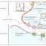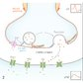

Neuromuscular junction (NMJ)
- Definition: a type of chemical synapse that occurs between alpha motor neurons and skeletal muscle
- Motor unit: an alpha motor neuron together with the group of muscle fibers it innervates
- Presynaptic neuron: action potential → depolarization of the presynaptic membrane → opening of voltage-gated Ca²⁺ channels → influx of Ca²⁺ into the presynaptic terminal → SNARE complex-mediated fusion of vesicles with the presynaptic membrane → release of acetylcholine (ACh) from vesicles into the synaptic cleft
- Muscle fiber: binding of ACh to its receptor on the postsynaptic membrane of muscle (motor end plate) → depolarization of the postsynaptic membrane → end-plate potential (EPP) → stimulation of voltage-sensitive dihydropyridine receptors (DHPR) → coupling with ryanodine receptors (RR) → release of Ca²⁺ from the sarcoplasmic reticulum (SR) → tropomyosin releases the myosin-binding site on actin → binding of myosin and actin → muscle contraction
- Synaptic cleft: acetylcholinesterase (AChE) breaks down ACh → acetate and choline → reuptake of choline into the presynaptic membrane → resynthesis of ACh
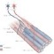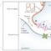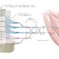

Electrical synapses
- A type of synapse that transmits signals between neurons joined by a gap junction by the flow of electrical current (i.e., movement of ions).
- Unlike chemical synapses, which require the transmission of a neurotransmitter across a cleft, electrical synapses transmit the signal directly and without delay.
- Found in the heart and smooth muscle
- Allows bidirectional flow of information between cells
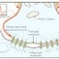
NOTES
FEEDBACK

Neurotrophic factors (NTFs)
- Definition: substances that enhance neuronal survival and differentiation
- Overview ^{[6][11][12]}
  - Neurons compete for survival-promoting agents during their development
  - NTFs ensure a match between the requirement for appropriate target innervation and the number of surviving neurons
  - Functions include regulation of nervous system development (e.g., cell proliferation, migration, differentiation, dendritic and axonal growth, synaptogenesis, synaptic plasticity), of regressive events (e.g., cell death or survival, axon and synapse elimination) after injury, and of synaptic competition and by modifying both synaptic transmission and structure
MAXIMIZE TABLETABLE QUIZ
Overview of NTFs (trophic and growth factors) ^{[6][12]}
Family | Examples | Functions
Neurotrophins | - Nerve growth factor; brain-derived neurotrophic factor; neurotrophin 3, 4, and 5 | - Neuronal survival and differentiation  - Involved in synaptic plasticity changes related to learning and memory
Neuropoietic cytokines and interleukins | - Ciliary neurotrophic factor, leukemia inhibitory factor, cardiotrophin like cytokine/cytokine-like factor  - IL-1α, IL-1β, IL-2 – IL-15 | - Motor neuron survival  - Immunoregulation
Tissue growth factors | - TGF-α, TGF-β, FGFs, IGF-Iα, IGF-Iβ, IGF-II, EGF, PDGF | - Cell proliferation and differentiation in diverse tissues and organs  - Effects on enteric, dopaminergic, and motor neurons
NOTES
FEEDBACK

References
1.
Terasaki M. Axonal endoplasmic reticulum is very narrow. J Cell Sci. 2018; 131(4): p.jcs210450. doi: 10.1242/jcs.210450.| Open in Read by QxMD
2.
Glass JD, Wesselingh SL, Selnes OA, McArthur JC. Clinical-neuropathologic correlation in HIV-associated dementia. Neurology. 1993; 43(11): p.2230-2230. doi: 10.1212/wnl.43.11.2230.| Open in Read by QxMD
3.
Raikwar SP, Bhagavan SM, Ramaswamy SB, et al. Are Tanycytes the Missing Link Between Type 2 Diabetes and Alzheimer’s Disease?. Mol Neurobiol. 2018; 56(2): p.833-843. doi: 10.1007/s12035-018-1123-8.| Open in Read by QxMD
4.
Felten DL, O'Banion MK, Maida ME. Netter's Atlas of Neuroscience. Amsterdam, The Netherlands: Elsevier Health Sciences; 2015
5.
Jessen KR, Mirsky R. The repair Schwann cell and its function in regenerating nerves. J Physiol. 2016; 594(13): p.3521-3531. doi: 10.1113/jp270874.| Open in Read by QxMD
6.
Squire L, Berg D, Bloom FE, du Lac S, Ghosh A, Spitzer NC. Fundamental Neuroscience. Academic Press; 2013
7.
Marios Politis, Flavia Niccolini. Serotonin in Parkinson's disease. Behav Brain Res. 2015; 277: p.136-145. doi: 10.1016/j.bbr.2014.07.037.| Open in Read by QxMD
8.
Tarsa L, Goda Y. Synaptophysin regulates activity-dependent synapse formation in cultured hippocampal neurons. Proceedings of the National Academy of Sciences. 2002; 99(2): p.1012-1016. doi: 10.1073/pnas.022575999.| Open in Read by QxMD
9.
Hammond C, El Far O, Seagar M. Neurotransmitter release. Elsevier; 2015: p. 145-169
10.
Purves. Neuroscience. https://www.ncbi.nlm.nih.gov/books/NBK11117/. Updated: January 1, 2001. Accessed: January 7, 2022.
11.
Huang EJ, Reichardt LF. Neurotrophins: Roles in Neuronal Development and Function. Annu Rev Neurosci. 2001; 24(1): p.677-736. doi: 10.1146/annurev.neuro.24.1.677.| Open in Read by QxMD
12.
Siegel GJ, Agranoff BW, Albers RW et al. Basic Neurochemistry: Molecular, Cellular and Medical Aspects. Philadelphia, PA, USA: Lippincott-Raven; 1999

